[](https://www.google.pl/url?sa=i&url=http://dewocjonalia-roza.pl/baranek-wielkanocny-p-887.html&psig=AOvVaw1yNQ8ivVvVYOKc5Qg2SETe&ust=1585820694175000&source=images&cd=vfe&ved=0CAIQjRxqFwoTCIiV8v75xugCFQAAAAAdAAAAABAD) [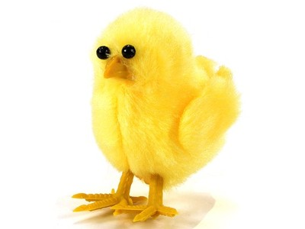](https://www.google.pl/url?sa=i&url=https://archiwum.allegro.pl/oferta/kurczak-kurczaki-wielkanoc-stroik-xl-kurka-6cm-ds-i6710136036.html&psig=AOvVaw1w52m-ZSsROsE0koYlOZo7&ust=1585821116383000&source=images&cd=vfe&ved=0CAIQjRxqFwoTCPCQn5v6xugCFQAAAAAdAAAAABAV)

[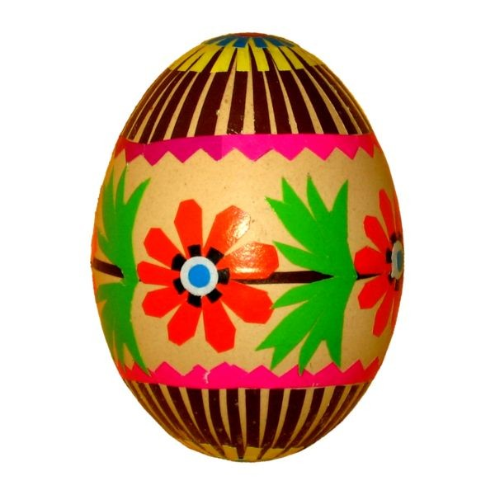](https://www.google.pl/url?sa=i&url=https://puzzlefactory.pl/pl/puzzle/graj/wielkanoc/159025-kolorowa-pisanka-ludowa&psig=AOvVaw2CjP7eYil6V_UqjDVdvK8X&ust=1585821233963000&source=images&cd=vfe&ved=0CAIQjRxqFwoTCPD3tM76xugCFQAAAAAdAAAAABAJ) [](https://www.google.pl/url?sa=i&url=https://haft-wzory.pl/produkt/bazie-haft-komputerowy-9cm-x-175cm/&psig=AOvVaw0Vbf3kbsfoOExkf80q6rew&ust=1585821306896000&source=images&cd=vfe&ved=0CAIQjRxqFwoTCNDtwfH6xugCFQAAAAAdAAAAABAI)[](https://www.google.pl/url?sa=i&url=https://www.m-shop.eu/product-pol-27138-Folkstar-Bombka-FOLK-ozdoba-choinkowa-LOWICKA-CZARNA-FOLK-CHRISTMAS-BAUBLE.html&psig=AOvVaw0-Z3yIe7ZFQ9kFjL8GG0U3&ust=1585822014731000&source=images&cd=vfe&ved=0CAIQjRxqFwoTCODLgsT9xugCFQAAAAAdAAAAABAD)[](https://www.google.pl/url?sa=i&url=https://www.pocztakwiatowa.pl/udekorowana-zywa-choinka&psig=AOvVaw0TWllcNart_pPbkowpfeKG&ust=1585822118839000&source=images&cd=vfe&ved=0CAIQjRxqFwoTCPDxo_X9xugCFQAAAAAdAAAAABAD)[](https://www.google.pl/url?sa=i&url=https://kasandra.com.pl/poduszka-ksztaltka-40x40-cm-mikolaj-p-12880.html&psig=AOvVaw0OV-KejSsmI-ihw55eVeiY&ust=1585822180979000&source=images&cd=vfe&ved=0CAIQjRxqFwoTCODXkZH-xugCFQAAAAAdAAAAABAD)