[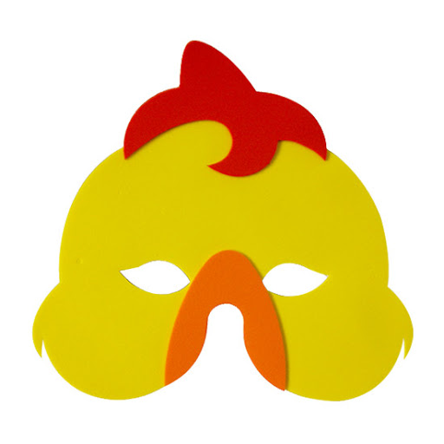](https://www.google.pl/url?sa=i&url=http://www.millytoys.com.br/produtos/mascaras&psig=AOvVaw1hT2e3KX9Um-_hsu82j7yf&ust=1585818059465000&source=images&cd=vfe&ved=0CAIQjRxqFwoTCJDH96rvxugCFQAAAAAdAAAAABAh)