[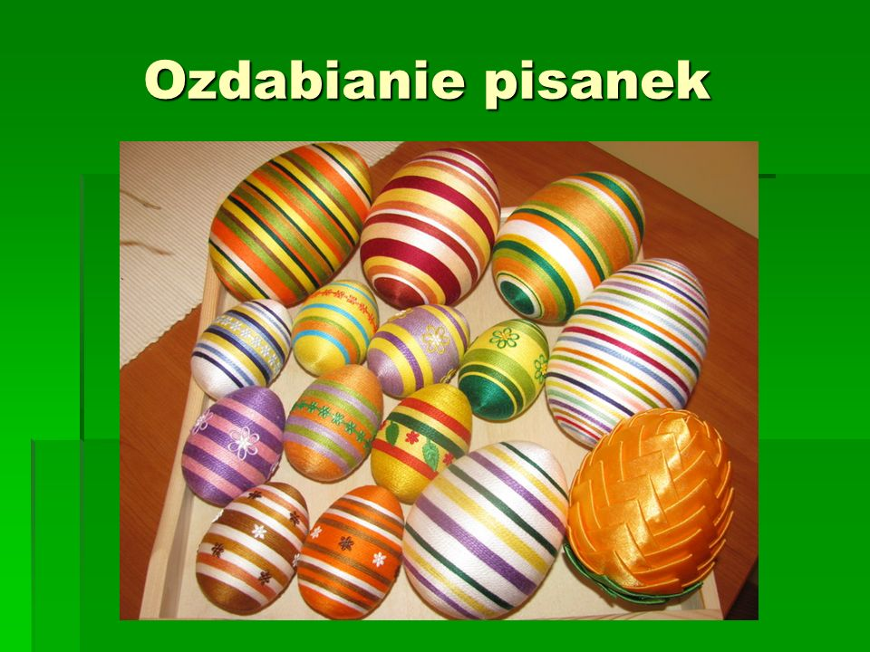](https://www.google.pl/url?sa=i&url=https://slideplayer.pl/slide/817986/&psig=AOvVaw2j3q0UAVYFkeaHx470eDhU&ust=1585766153458000&source=images&cd=vfe&ved=0CAIQjRxqFwoTCLif0LStxegCFQAAAAAdAAAAABAD)

[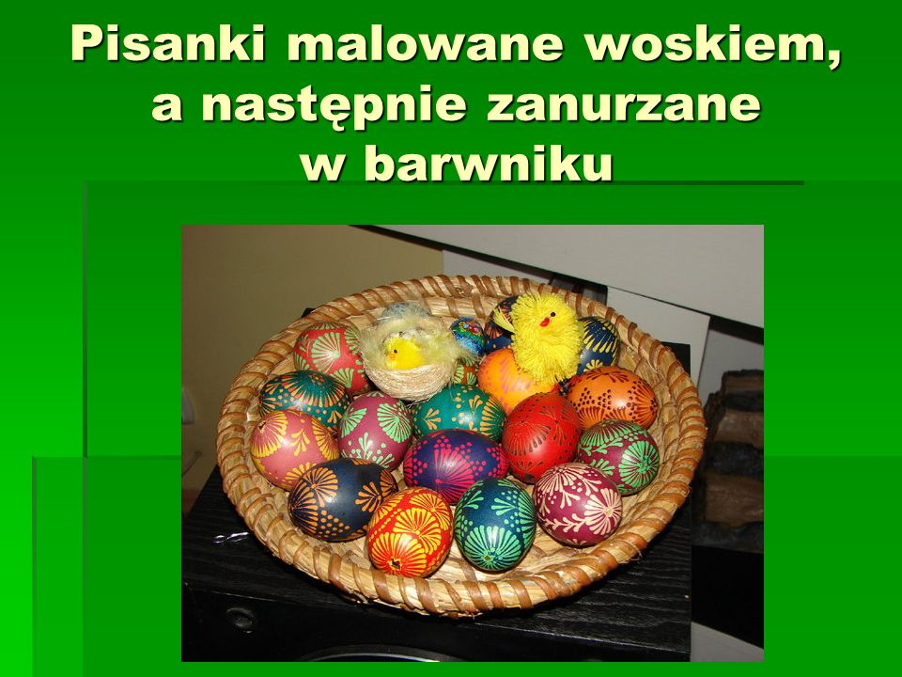](https://www.google.pl/url?sa=i&url=https://slideplayer.pl/slide/817986/&psig=AOvVaw2j3q0UAVYFkeaHx470eDhU&ust=1585766153458000&source=images&cd=vfe&ved=0CAIQjRxqFwoTCLif0LStxegCFQAAAAAdAAAAABAI)

[](https://www.google.pl/url?sa=i&url=https://slideplayer.pl/slide/817986/&psig=AOvVaw2j3q0UAVYFkeaHx470eDhU&ust=1585766153458000&source=images&cd=vfe&ved=0CAIQjRxqFwoTCLif0LStxegCFQAAAAAdAAAAABAM)

[](https://www.google.pl/url?sa=i&url=https://slideplayer.pl/slide/817986/&psig=AOvVaw2j3q0UAVYFkeaHx470eDhU&ust=1585766153458000&source=images&cd=vfe&ved=0CAIQjRxqFwoTCLif0LStxegCFQAAAAAdAAAAABAQ)