[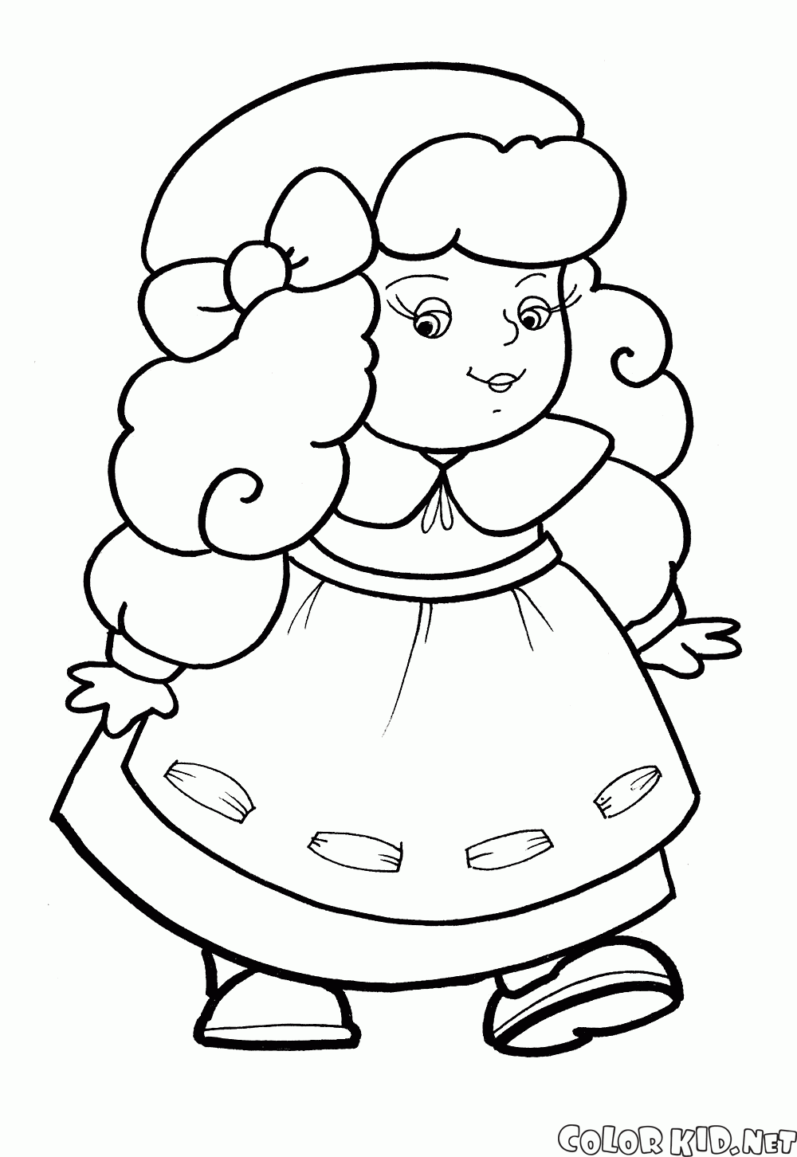](https://www.google.pl/url?sa=i&url=http%3A%2F%2Fpl.colorkid.net%2Fkolorowanki-dla-ma%25C5%2582ych-dzieci%2Fkolorowanki-zabawki%2Fkolorowanka-zabawki-dla-dziewczynek&psig=AOvVaw2cpsveHa7v018z1SWyaFtV&ust=1591185795573000&source=images&cd=vfe&ved=0CAIQjRxqFwoTCKDE_pOL4-kCFQAAAAAdAAAAABAD)[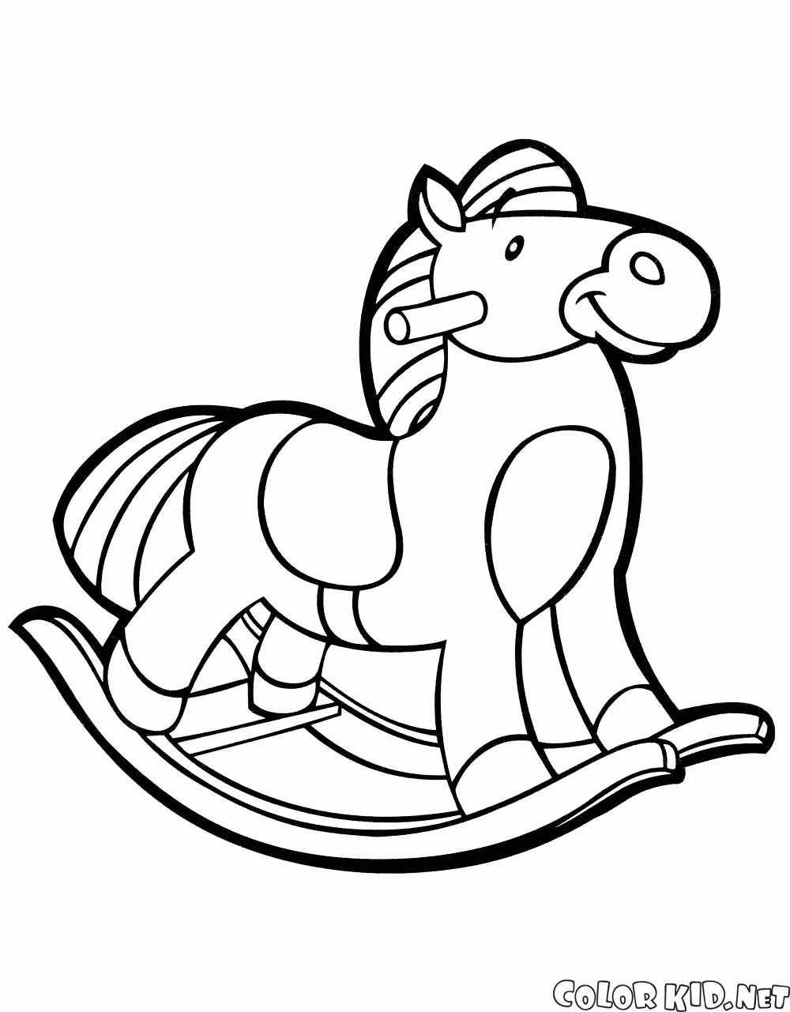](https://www.google.pl/url?sa=i&url=http%3A%2F%2Fpl.colorkid.net%2Fkolorowanki-dla-ma%25C5%2582ych-dzieci%2Fkolorowanki-zabawki%2Fkolorowanka-toy-konia&psig=AOvVaw2cpsveHa7v018z1SWyaFtV&ust=1591185795573000&source=images&cd=vfe&ved=0CAIQjRxqFwoTCKDE_pOL4-kCFQAAAAAdAAAAABAI)[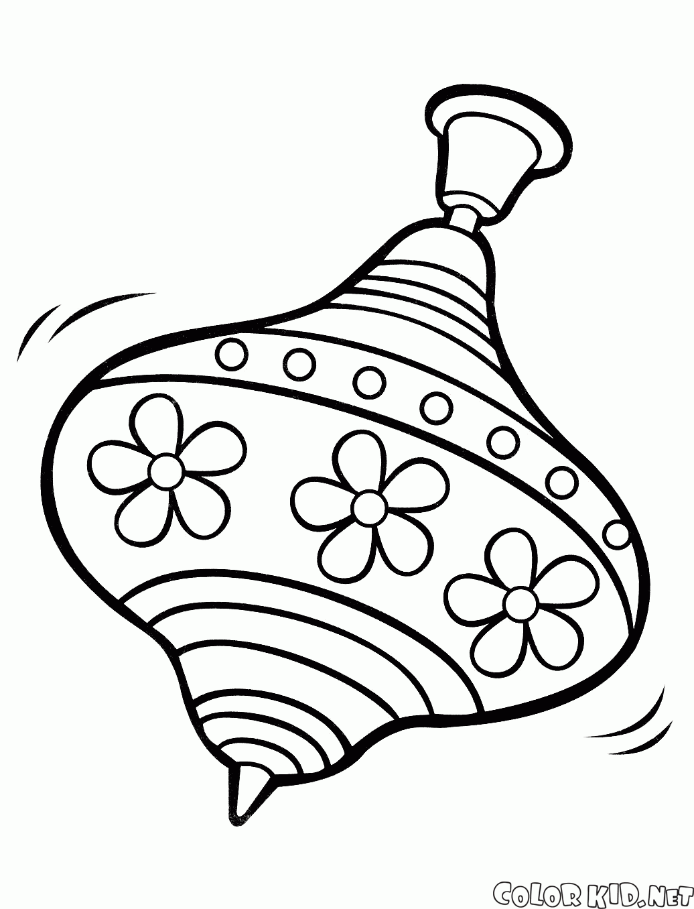](https://www.google.pl/url?sa=i&url=http%3A%2F%2Fpl.colorkid.net%2Fkolorowanki-dla-ma%25C5%2582ych-dzieci%2Fkolorowanki-zabawki%2Fkolorowanka-b%25C4%2585k&psig=AOvVaw2cpsveHa7v018z1SWyaFtV&ust=1591185795573000&source=images&cd=vfe&ved=0CAIQjRxqFwoTCKDE_pOL4-kCFQAAAAAdAAAAABAN)[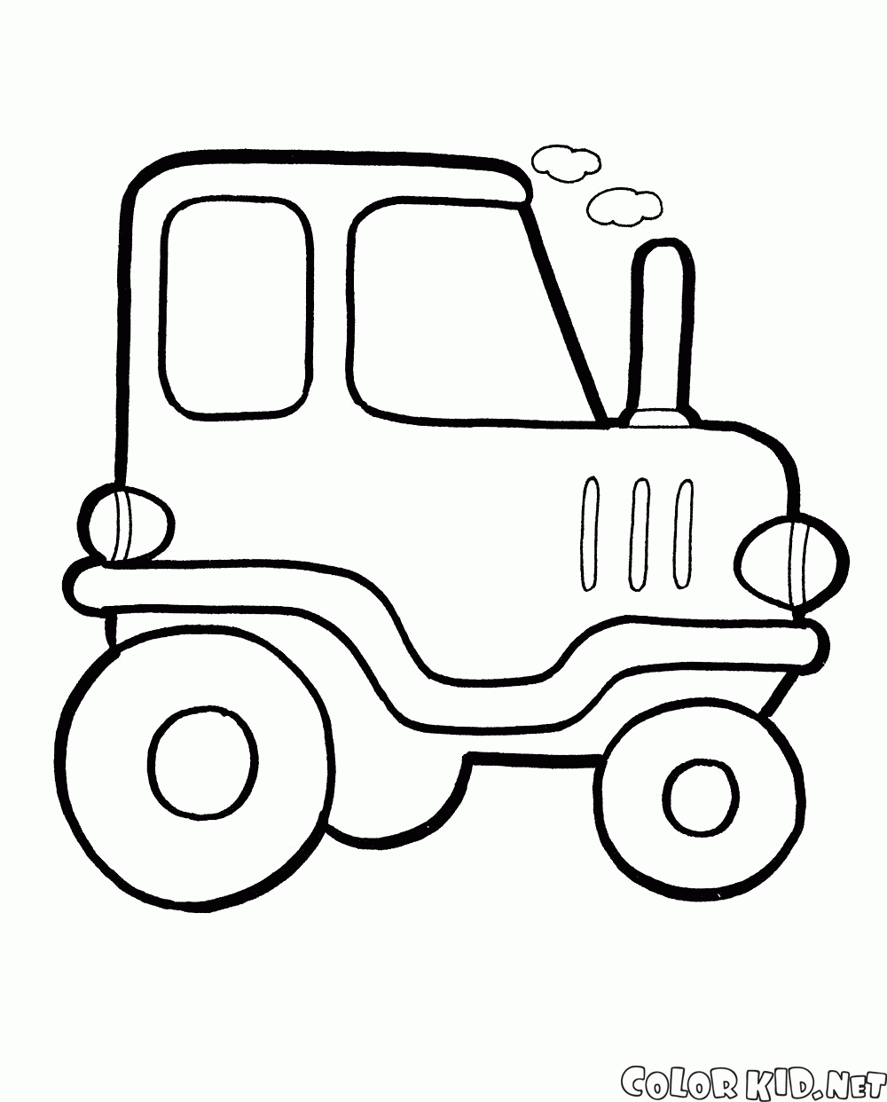](https://www.google.pl/url?sa=i&url=http%3A%2F%2Fpl.colorkid.net%2Fkolorowanki-dla-ma%25C5%2582ych-dzieci%2Fkolorowanki-zabawki%2Fkolorowanka-samochodzik&psig=AOvVaw2cpsveHa7v018z1SWyaFtV&ust=1591185795573000&source=images&cd=vfe&ved=0CAIQjRxqFwoTCKDE_pOL4-kCFQAAAAAdAAAAABAS)