[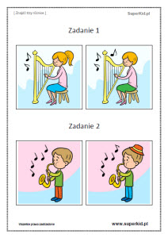](https://www.google.pl/url?sa=i&url=https%3A%2F%2Fwww.superkid.pl%2Fcwiczenia-dla-maluszkow-znajdz-3-roznice&psig=AOvVaw3p5cRg0D3-_o90EMFTYYUG&ust=1591179700000000&source=images&cd=vfe&ved=0CAIQjRxqFwoTCNCCxbn04ukCFQAAAAAdAAAAABAI)