[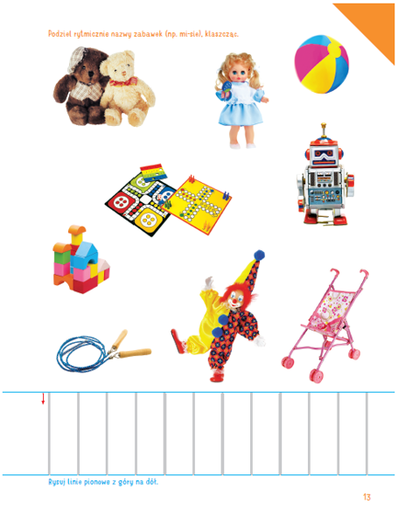](https://www.google.pl/url?sa=i&url=https%3A%2F%2Fksiegarnia-edukacyjna.pl%2Fproduct-pol-14965-Olek-i-Ada-Pieciolatek-Poziom-B-Karty-pracy-cz-1.html&psig=AOvVaw1c2Tn7Q4M_cc_ajkFThnqw&ust=1591103273742000&source=images&cd=vfe&ved=0CAIQjRxqFwoTCLCyt5DY4OkCFQAAAAAdAAAAABAI)