[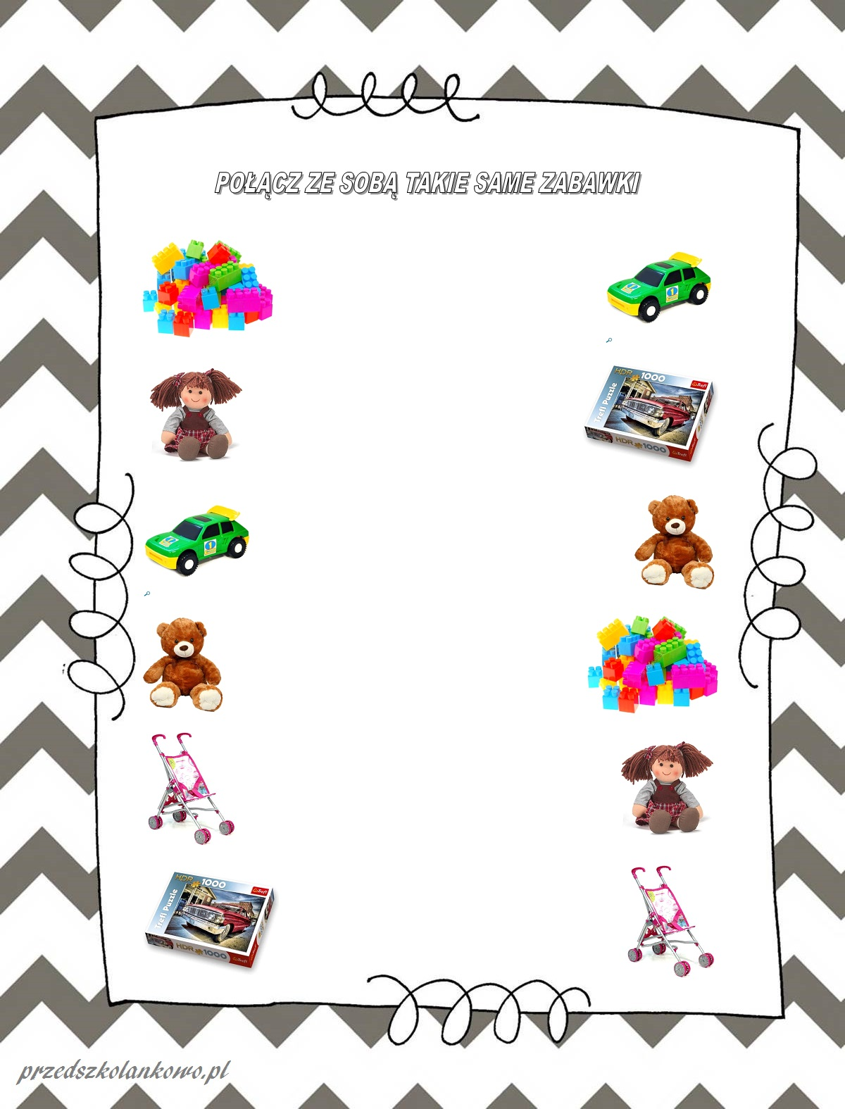](https://www.google.pl/url?sa=i&url=https%3A%2F%2Fprzedszkolankowo.pl%2F2016%2F11%2F21%2Fpolacz-w-pary-karty-pracy-zestaw-1%2F&psig=AOvVaw1c2Tn7Q4M_cc_ajkFThnqw&ust=1591103273742000&source=images&cd=vfe&ved=0CAIQjRxqFwoTCLCyt5DY4OkCFQAAAAAdAAAAABAD)