[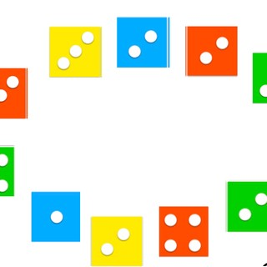](https://www.google.pl/url?sa=i&url=https%3A%2F%2Fwww.berdo.org%2Fkartoniki-z-kropkami-figury-liczbow&psig=AOvVaw2lDxMRQk5dM0pEE13Xjux1&ust=1591099023600000&source=images&cd=vfe&ved=0CAIQjRxqFwoTCMCl7PPH4OkCFQAAAAAdAAAAABAm) [](https://www.google.pl/url?sa=i&url=https%3A%2F%2Fwww.berdo.org%2Fkartoniki-z-kropkami-figury-liczbow&psig=AOvVaw2lDxMRQk5dM0pEE13Xjux1&ust=1591099023600000&source=images&cd=vfe&ved=0CAIQjRxqFwoTCMCl7PPH4OkCFQAAAAAdAAAAABAm) [](https://www.google.pl/url?sa=i&url=https%3A%2F%2Fwww.berdo.org%2Fkartoniki-z-kropkami-figury-liczbow&psig=AOvVaw2lDxMRQk5dM0pEE13Xjux1&ust=1591099023600000&source=images&cd=vfe&ved=0CAIQjRxqFwoTCMCl7PPH4OkCFQAAAAAdAAAAABAm) [](https://www.google.pl/url?sa=i&url=https%3A%2F%2Fwww.berdo.org%2Fkartoniki-z-kropkami-figury-liczbow&psig=AOvVaw2lDxMRQk5dM0pEE13Xjux1&ust=1591099023600000&source=images&cd=vfe&ved=0CAIQjRxqFwoTCMCl7PPH4OkCFQAAAAAdAAAAABAm)