[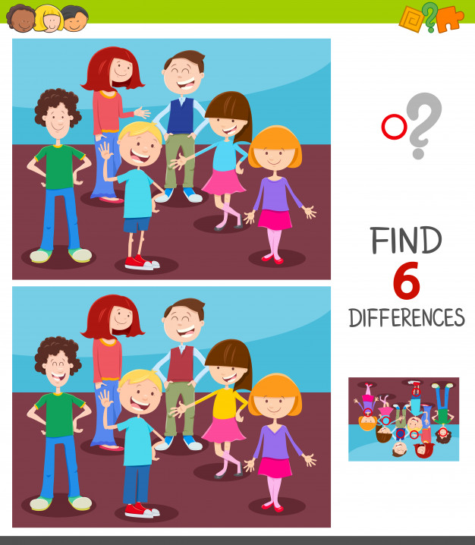](https://www.google.pl/url?sa=i&url=https%3A%2F%2Fpl.freepik.com%2Fpremium-wektory%2Fwyszukiwanie-roznic-miedzy-obrazkami-gra-dla-dzieci_4108699.htm&psig=AOvVaw2LUS2LlOKqHTujsjSHBSsI&ust=1590935638442000&source=images&cd=vfe&ved=0CAIQjRxqFwoTCKi0mqPn2-kCFQAAAAAdAAAAABAO)