[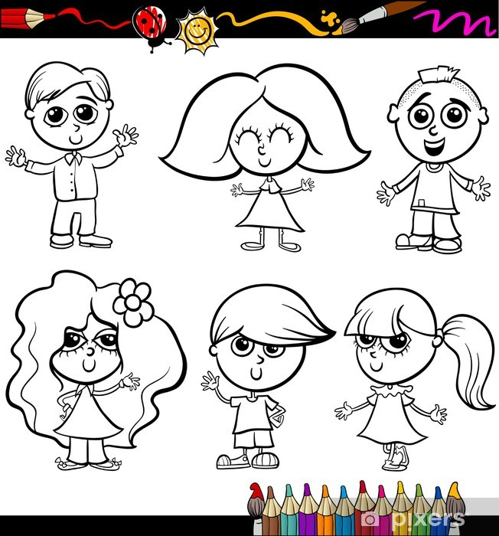](https://www.google.pl/url?sa=i&url=https%3A%2F%2Fpixers.pl%2Ffototapety%2Fdzieci-cartoon-dla-kolorowanka-59295127&psig=AOvVaw3RA3FXCUZ2MNs7OVPW0oYz&ust=1590936610120000&source=images&cd=vfe&ved=0CAIQjRxqFwoTCLCvporr2-kCFQAAAAAdAAAAABAP)