[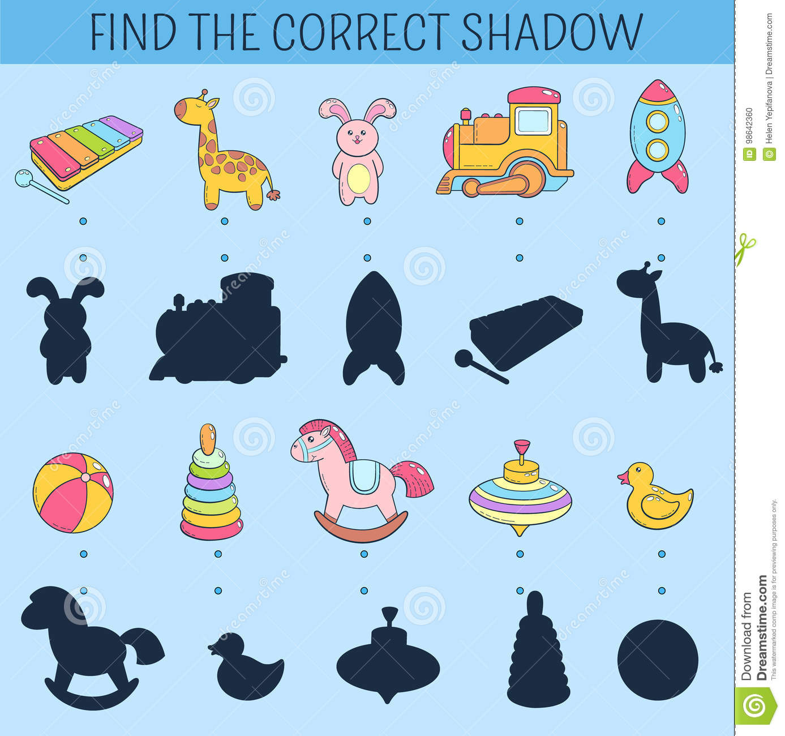](https://www.google.pl/url?sa=i&url=https%3A%2F%2Fwww.dreamstime.com%2Fstock-illustration-find-correct-shadow-educational-game-children-vector-hand-drawn-doodle-illustration-cartoon-kids-toys-image98642360&psig=AOvVaw0zNrrWBTGwhFKV6aWv2Efw&ust=1590687014372000&source=images&cd=vfe&ved=0CAIQjRxqFwoTCNCciIrJ1OkCFQAAAAAdAAAAABAY)