[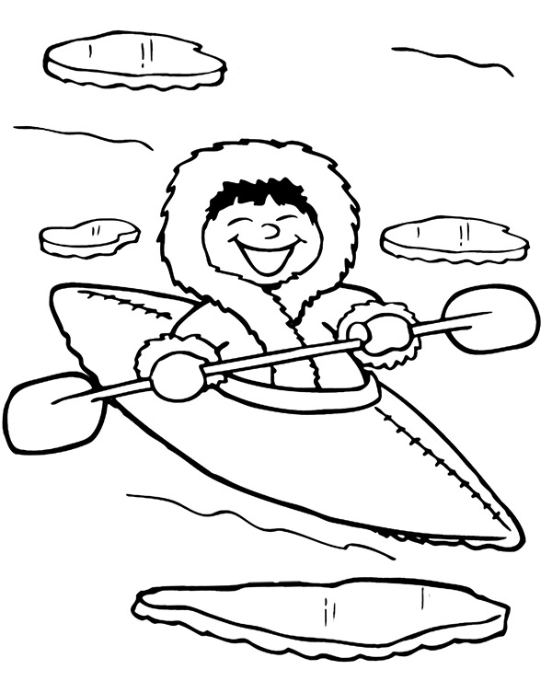](https://www.google.pl/url?sa=i&url=https%3A%2F%2Fwww.e-kolorowanki.eu%2Fkolorowanki-zima%2Fkolorowanka-z-eskimosem%2F&psig=AOvVaw0hF1M2MfA0u8QPxRI7yWmz&ust=1590687893250000&source=images&cd=vfe&ved=0CAIQjRxqFwoTCJD1rqnM1OkCFQAAAAAdAAAAABAO)