[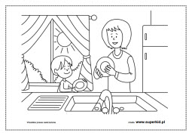](https://www.google.pl/url?sa=i&url=https%3A%2F%2Fwww.superkid.pl%2Fkolorowanki-rodzina&psig=AOvVaw0ROYHUENy-JwHMPl_73_zo&ust=1590496511538000&source=images&cd=vfe&ved=0CAIQjRxqFwoTCLjCm6-Dz-kCFQAAAAAdAAAAABAO)