[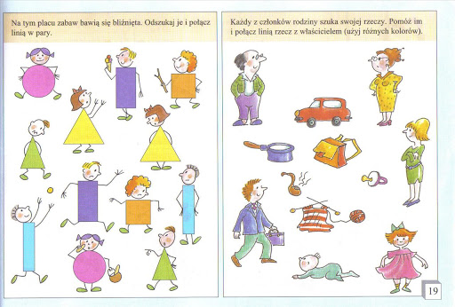](https://www.google.pl/url?sa=i&url=https%3A%2F%2Fwww.gov.pl%2Fweb%2Fzdalnelekcje%2Fmoja-rodzina&psig=AOvVaw1fncel9DWL-KW8K87LtMuU&ust=1590414615900000&source=images&cd=vfe&ved=0CAIQjRxqFwoTCOCRoKvSzOkCFQAAAAAdAAAAABAP)