[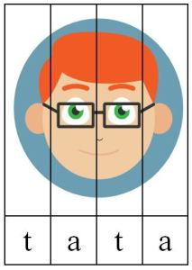](https://www.google.pl/url?sa=i&url=https%3A%2F%2Fpanimonia.pl%2F2017%2F10%2F29%2Fja-moja-rodzina-gigapaka-przedszkolaka%2F&psig=AOvVaw0piUndbru5qDJPjSfSbIMg&ust=1590416597729000&source=images&cd=vfe&ved=0CAIQjRxqFwoTCIijvNjZzOkCFQAAAAAdAAAAABAD)