[](https://www.google.pl/url?sa=i&url=https%3A%2F%2Fallegro.pl%2Fserce-sklejki-drewniane-scrapki-10-cm-czerwone-w1-i7258755162.html&psig=AOvVaw0ZCW7n7m-6KNtowXQA1KU9&ust=1590151262889000&source=images&cd=vfe&ved=0CAIQjRxqFwoTCKj2yZz9xOkCFQAAAAAdAAAAABAD)[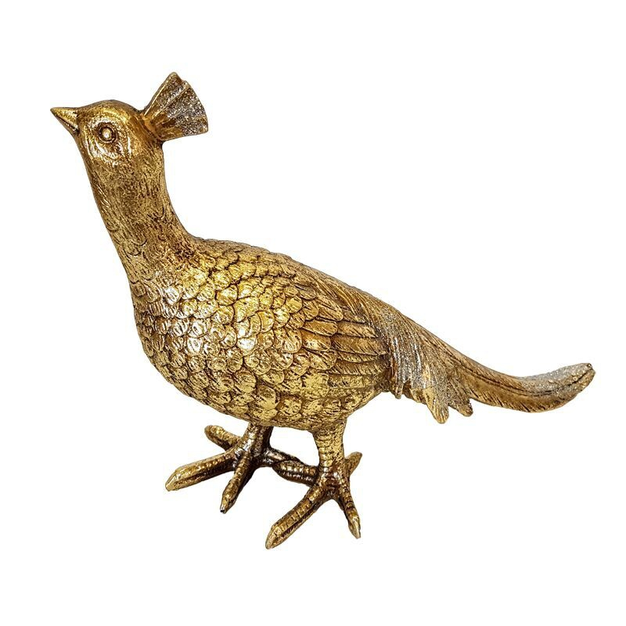](https://www.google.pl/url?sa=i&url=https%3A%2F%2Fwww.villadecor.pl%2Ffigurki-wazy-luksusowe-dekoracje%2F4922-elegancki-zloty-ptak-feniks-art-deco.html&psig=AOvVaw0-5YnJbvLeYVfd3_fL91K-&ust=1590151307174000&source=images&cd=vfe&ved=0CAIQjRxqFwoTCOCa17L9xOkCFQAAAAAdAAAAABAN)