[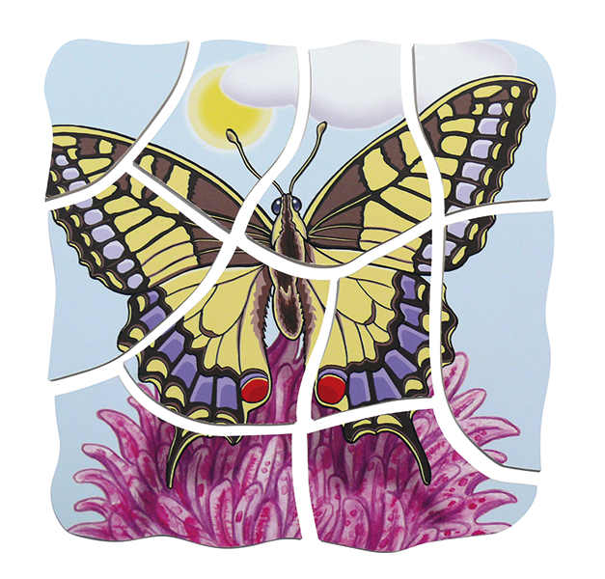](https://www.google.pl/url?sa=i&url=https%3A%2F%2Fksiegarnia-edukacyjna.pl%2Fproduct-pol-5443-Puzzle-Motyl.html&psig=AOvVaw2TgQWHv9khRspGZsby8Vns&ust=1589547590060000&source=images&cd=vfe&ved=0CAIQjRxqFwoTCMD72a60s-kCFQAAAAAdAAAAABAD)