[](https://www.google.pl/url?sa=i&url=https%3A%2F%2Fuwalls.pl%2Ffototapety-kwiat-maku-5133%2F&psig=AOvVaw2bK8SWNvyssfyz5x9iJY6A&ust=1589546607996000&source=images&cd=vfe&ved=0CAIQjRxqFwoTCNCNjtqws-kCFQAAAAAdAAAAABAD)[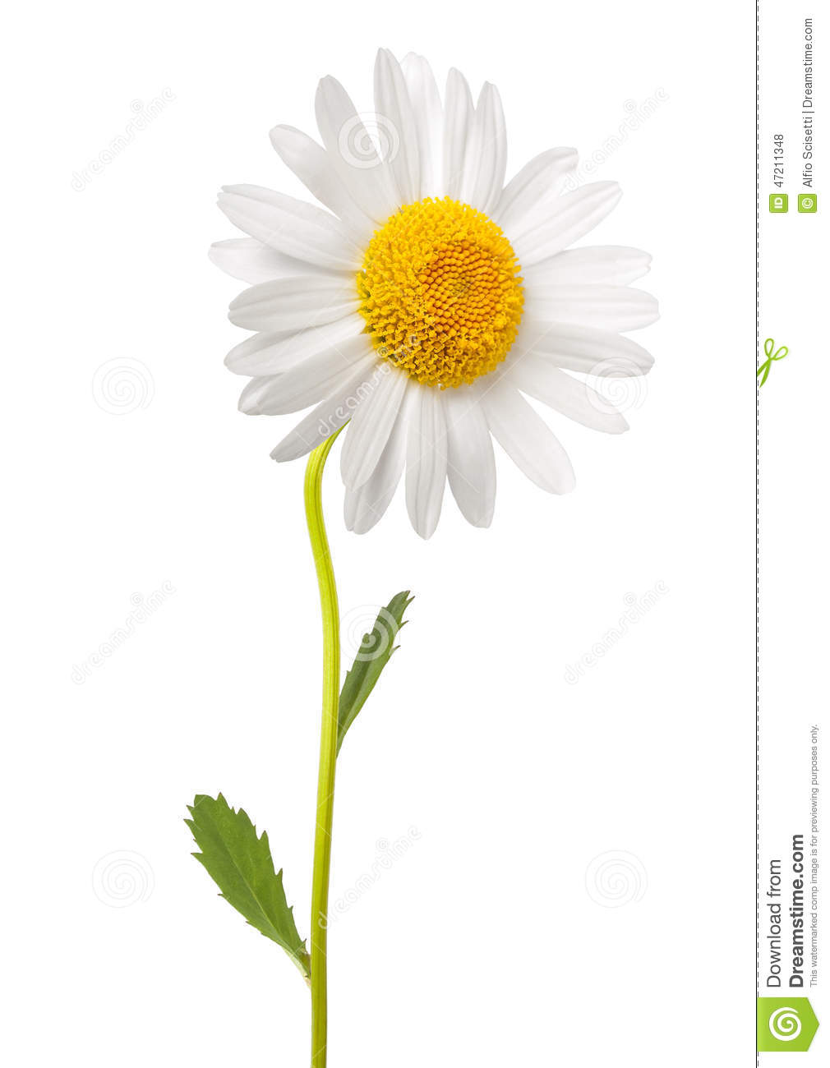](https://www.google.pl/url?sa=i&url=https%3A%2F%2Fpl.dreamstime.com%2Fzdj%25C4%2599cie-stock-bia%25C5%2582a-stokrotka-image47211348&psig=AOvVaw3S5DcgM44D4nAMffRaz__A&ust=1589546723130000&source=images&cd=vfe&ved=0CAIQjRxqFwoTCIC7n5Oxs-kCFQAAAAAdAAAAABAJ)[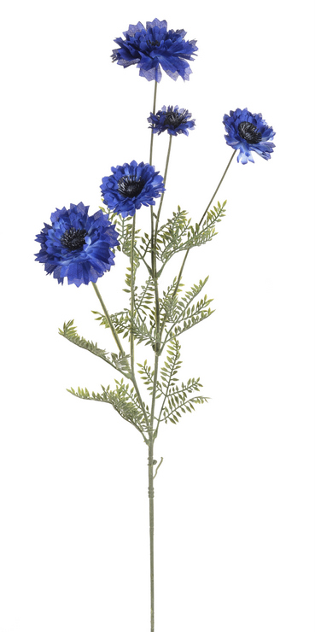](https://www.google.pl/url?sa=i&url=https%3A%2F%2Fallegro.pl%2Fchaber-sztuczna-roslina-wys-73-cm-s-053-i7724705569.html&psig=AOvVaw1LN9td3eEcoUk3MEaeTaDB&ust=1589546876284000&source=images&cd=vfe&ved=0CAIQjRxqFwoTCPih49yxs-kCFQAAAAAdAAAAABAJ)[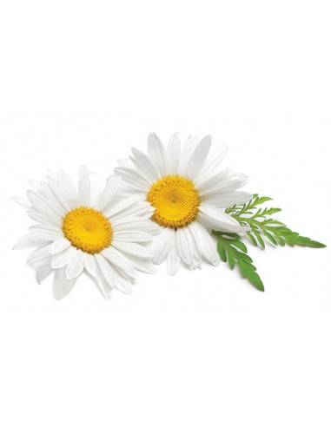](https://www.google.pl/url?sa=i&url=https%3A%2F%2Fvaporshop.pl%2Fpl%2Fstrona-glowna%2F2924-rumianek-bio-susz-do-waporyzacji-i-aromaterapii.html&psig=AOvVaw3llEgZmVo4WIshuPtaREnc&ust=1589547079036000&source=images&cd=vfe&ved=0CAIQjRxqFwoTCNCPhbuys-kCFQAAAAAdAAAAABAO)