[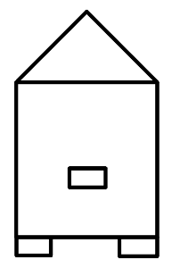](https://www.google.pl/url?sa=i&url=http%3A%2F%2Fwww.sp3.laziska.pl%2Flogo.php%3Fdzial%3Dlogo%26go%3Dzadania&psig=AOvVaw1uQ6T5R_ZjaZYga7R7mOMj&ust=1589474804798000&source=images&cd=vfe&ved=0CAIQjRxqFwoTCKDG-p-lsekCFQAAAAAdAAAAABAK)[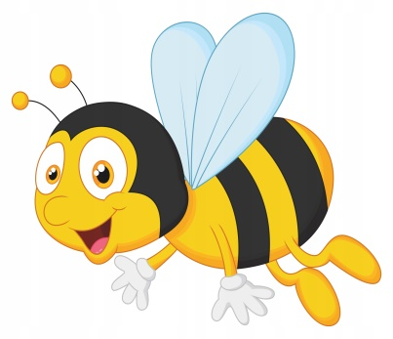](https://www.google.pl/url?sa=i&url=https%3A%2F%2Fallegro.pl%2Foferta%2Fnaklejka-na-okno-meble-lustro-pszczolka-pszczola-7865950708&psig=AOvVaw21OTxK0lyFTC50KmSAdyI-&ust=1589474925040000&source=images&cd=vfe&ved=0CAIQjRxqFwoTCJjEltilsekCFQAAAAAdAAAAABAJ)[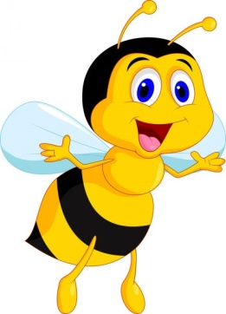](https://www.google.pl/url?sa=i&url=https%3A%2F%2Fpl.depositphotos.com%2Fvector-images%2Fpszczo%25C5%2582a.html&psig=AOvVaw1qicZ9-aDbHNhD-VG9yILG&ust=1589475009920000&source=images&cd=vfe&ved=0CAIQjRxqFwoTCKD9lYCmsekCFQAAAAAdAAAAABAD)