[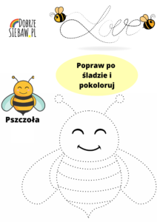](https://www.google.pl/url?sa=i&url=http%3A%2F%2Fdobrzesiebaw.pl%2Fwiosenne-karty-pracy-do-pobrania-prace-plastyczne-pszczoly%2F&psig=AOvVaw36VdJBX4I17mwli91mOcVM&ust=1589215560559000&source=images&cd=vfe&ved=0CAIQjRxqFwoTCLjamsXfqekCFQAAAAAdAAAAABAF)