[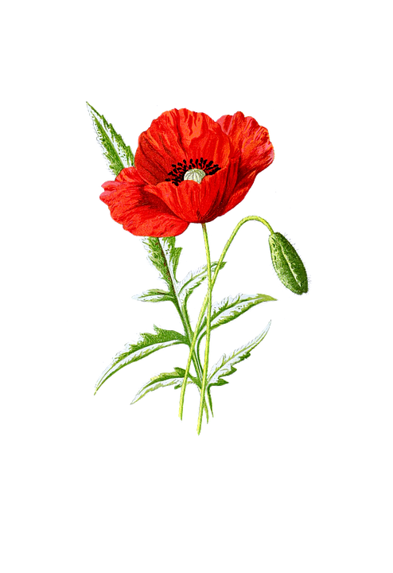](https://www.google.pl/url?sa=i&url=https://pixabay.com/pl/illustrations/mak-kwiat-czerwony-na-bia%C5%82ym-tle-1525814/&psig=AOvVaw2i672AB28riEry66WdTbRC&ust=1589214127645000&source=images&cd=vfe&ved=0CAIQjRxqFwoTCMiu7o7aqekCFQAAAAAdAAAAABAX)[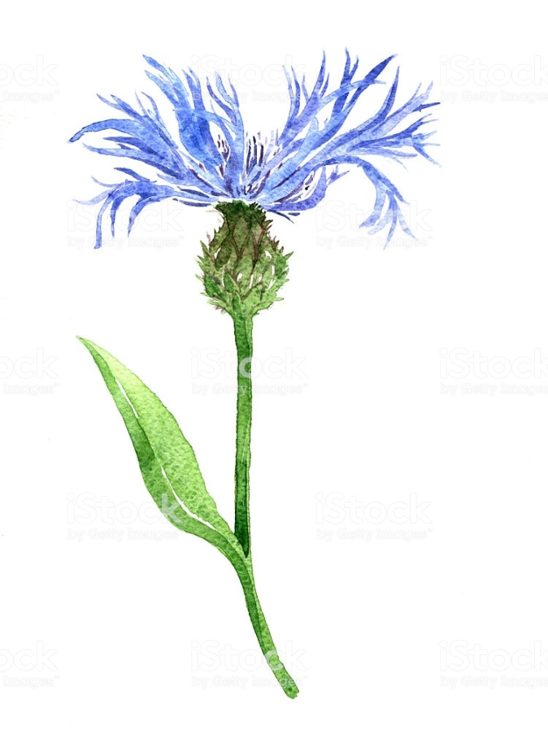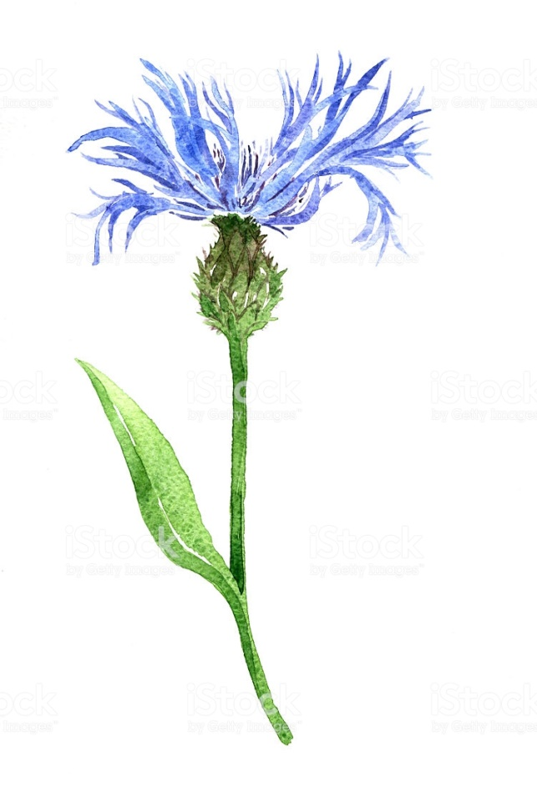](https://www.google.pl/url?sa=i&url=https://www.istockphoto.com/pl/wektor/chaber-rysunek-przez-watercolor-gm487654602-72977701&psig=AOvVaw13vGMrndaxuFUS6R7lthoL&ust=1589214292641000&source=images&cd=vfe&ved=0CAIQjRxqFwoTCPCk7N3aqekCFQAAAAAdAAAAABAD)[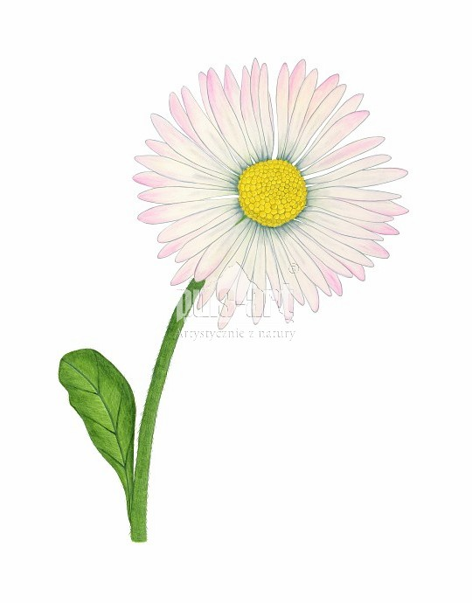](https://www.google.pl/url?sa=i&url=https%3A%2F%2Fwww.puls-art.pl%2Fprodukt%2Fstokrotka-pospolita-bellis-perennis%2F&psig=AOvVaw2TyO6JdbEVuG84vfok7w68&ust=1589214491468000&source=images&cd=vfe&ved=0CAIQjRxqFwoTCPCHo77bqekCFQAAAAAdAAAAABAD)[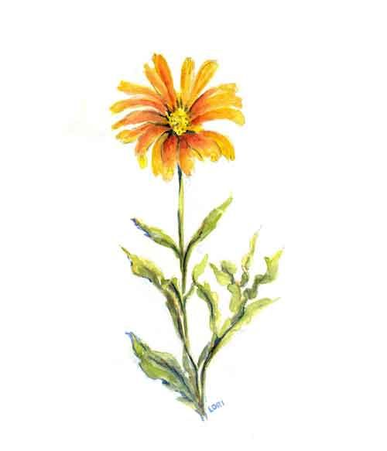](https://www.google.pl/url?sa=i&url=https%3A%2F%2Fwww.pinterest.com%2Fpin%2F805088870868736064%2F&psig=AOvVaw36IIJxHw7N6pSP8cN0WPSW&ust=1589214987345000&source=images&cd=vfe&ved=0CAIQjRxqFwoTCPDEiazdqekCFQAAAAAdAAAAABAT)

[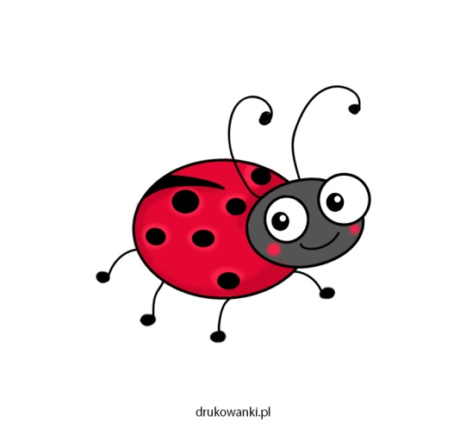](https://www.google.pl/url?sa=i&url=https%3A%2F%2Fwww.drukowanki.pl%2Fjak-narysowac-biedronke%2F&psig=AOvVaw2lzBNFmosOKnW1IYYPKtbW&ust=1589215201900000&source=images&cd=vfe&ved=0CAIQjRxqFwoTCOC07I_eqekCFQAAAAAdAAAAABAD)[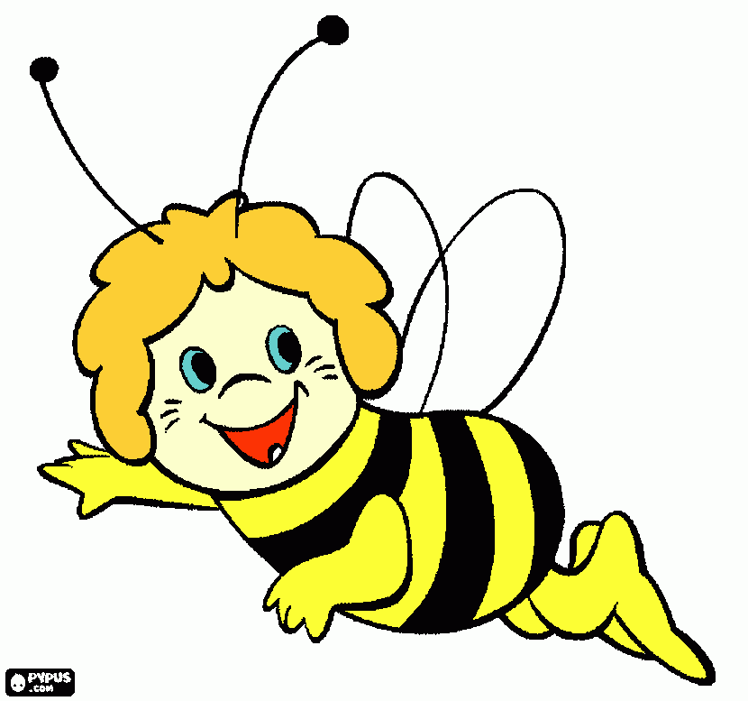](https://www.google.pl/url?sa=i&url=https%3A%2F%2Fwww.kolorowankimalowanki.pl%2Frysunke-pszczo%25C5%2582a_850158.html&psig=AOvVaw1D5SHrT3AxnVOzE9hN3fP9&ust=1589215261415000&source=images&cd=vfe&ved=0CAIQjRxqFwoTCKCL_7DeqekCFQAAAAAdAAAAABAD)[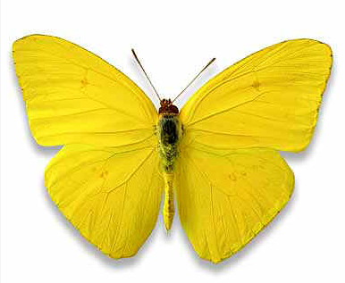](https://www.google.pl/url?sa=i&url=https%3A%2F%2Fwww.pinterest.com.mx%2Fpin%2F518758450820455652%2F&psig=AOvVaw0TyJcm2eL4Tqp0aaYVkZOs&ust=1589215346927000&source=images&cd=vfe&ved=0CAIQjRxqFwoTCMjdjNXeqekCFQAAAAAdAAAAABAJ)