[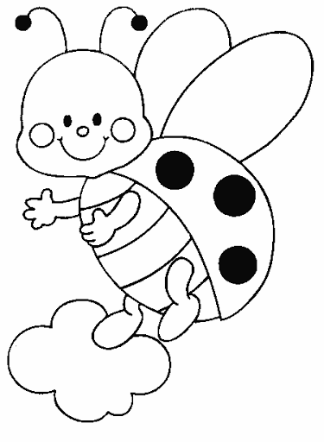](https://www.google.pl/url?sa=i&url=http%3A%2F%2Fe-kolorowanka.pl%2Fbiedronka-kolorowanki%2F3483-biedronki-kolorowanka-28.html&psig=AOvVaw1zvLk4xKHZl2lkfGj6IECb&ust=1589046972366000&source=images&cd=vfe&ved=0CAIQjRxqFwoTCPDSnLXrpOkCFQAAAAAdAAAAABAI)