[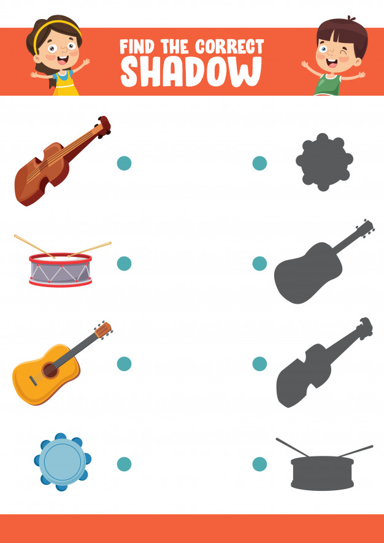](https://www.google.pl/url?sa=i&url=https%3A%2F%2Fwww.freepik.com%2Fpremium-vector%2Fvector-illustration-finding-correct-shadow-exercise_4370393.htm&psig=AOvVaw0Af2wepEfC7nSxRQ2vax_v&ust=1588775405378000&source=images&cd=vfe&ved=0CAIQjRxqFwoTCOj87N_3nOkCFQAAAAAdAAAAABAW)