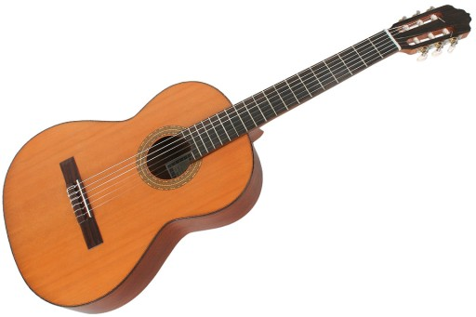 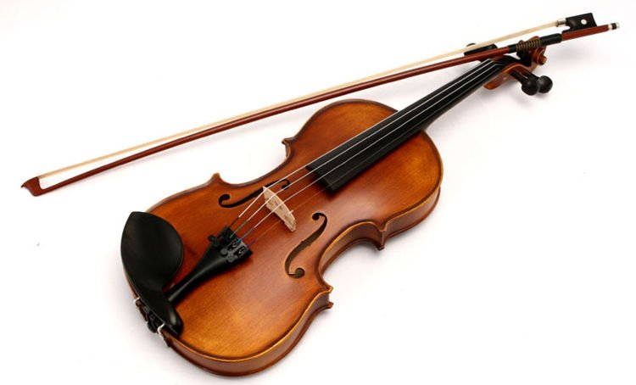 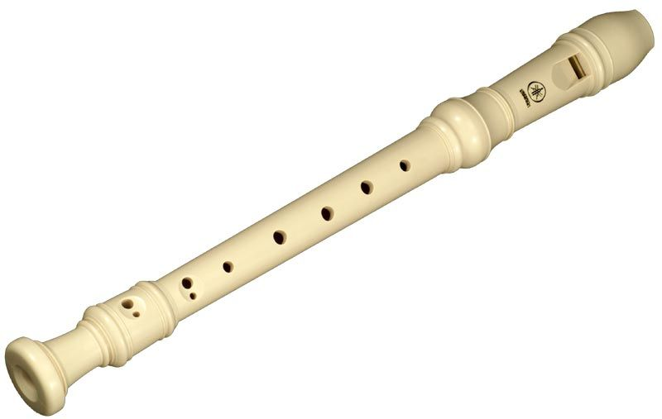 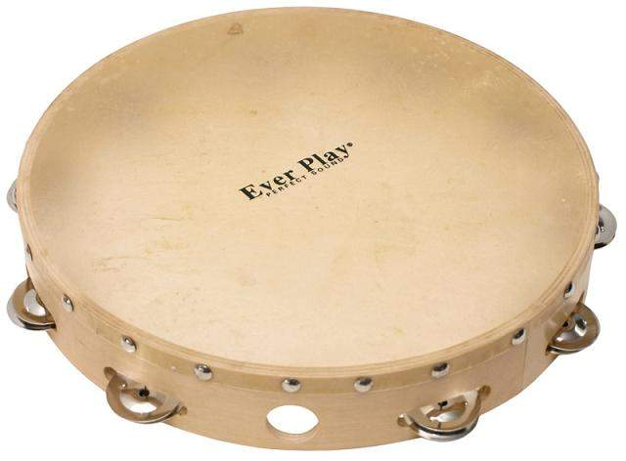 [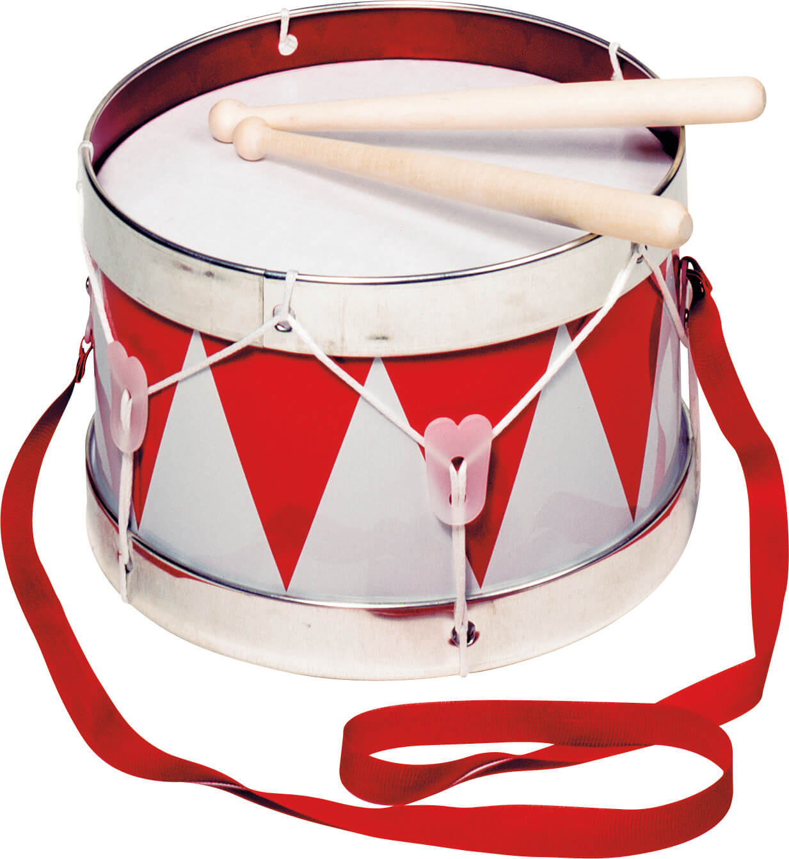](https://www.google.pl/url?sa=i&url=https%3A%2F%2Fwww.dobrezabawki.com%2Fprodukt%2Ftin-drum-bebenek&psig=AOvVaw12UwvEDO4w5ertIn7pHguA&ust=1588774971681000&source=images&cd=vfe&ved=0CAIQjRxqFwoTCKDJgZH2nOkCFQAAAAAdAAAAABAG) [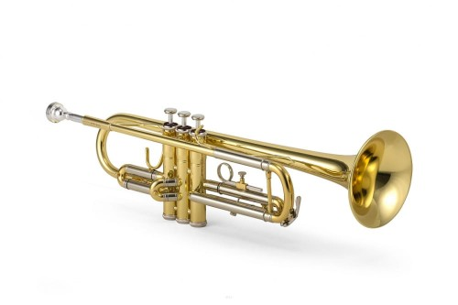](https://www.google.pl/url?sa=i&url=https%3A%2F%2Fpoludniowelutnictwo.pl%2Fpl%2Fp%2FTrabka-Jupiter-JTR600-futeral%2F414&psig=AOvVaw1GmCPsmCI_mx1xJFbNlREJ&ust=1588775102803000&source=images&cd=vfe&ved=0CAIQjRxqFwoTCMD_48_2nOkCFQAAAAAdAAAAABAD)