[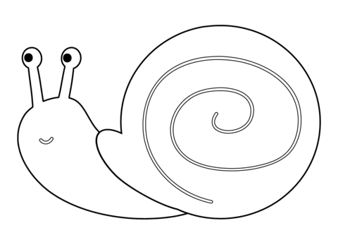](https://www.google.pl/url?sa=i&url=http%3A%2F%2Fwww.supercoloring.com%2Fpl%2Fkolorowanki%2Fslimak-3&psig=AOvVaw1jgTZ5YDXCiWY095QR3Zoj&ust=1588588820589000&source=images&cd=vfe&ved=0CAIQjRxqFwoTCLivotrAl-kCFQAAAAAdAAAAABAO)