[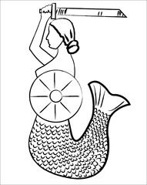](https://www.google.pl/url?sa=i&url=https%3A%2F%2Fwww.pinterest.es%2Fpin%2F550142910726011100%2F&psig=AOvVaw0QMWJHDq6KQb_TAhHmnLFx&ust=1587985222688000&source=images&cd=vfe&ved=0CAIQjRxqFwoTCND6i434hekCFQAAAAAdAAAAABAV)