

[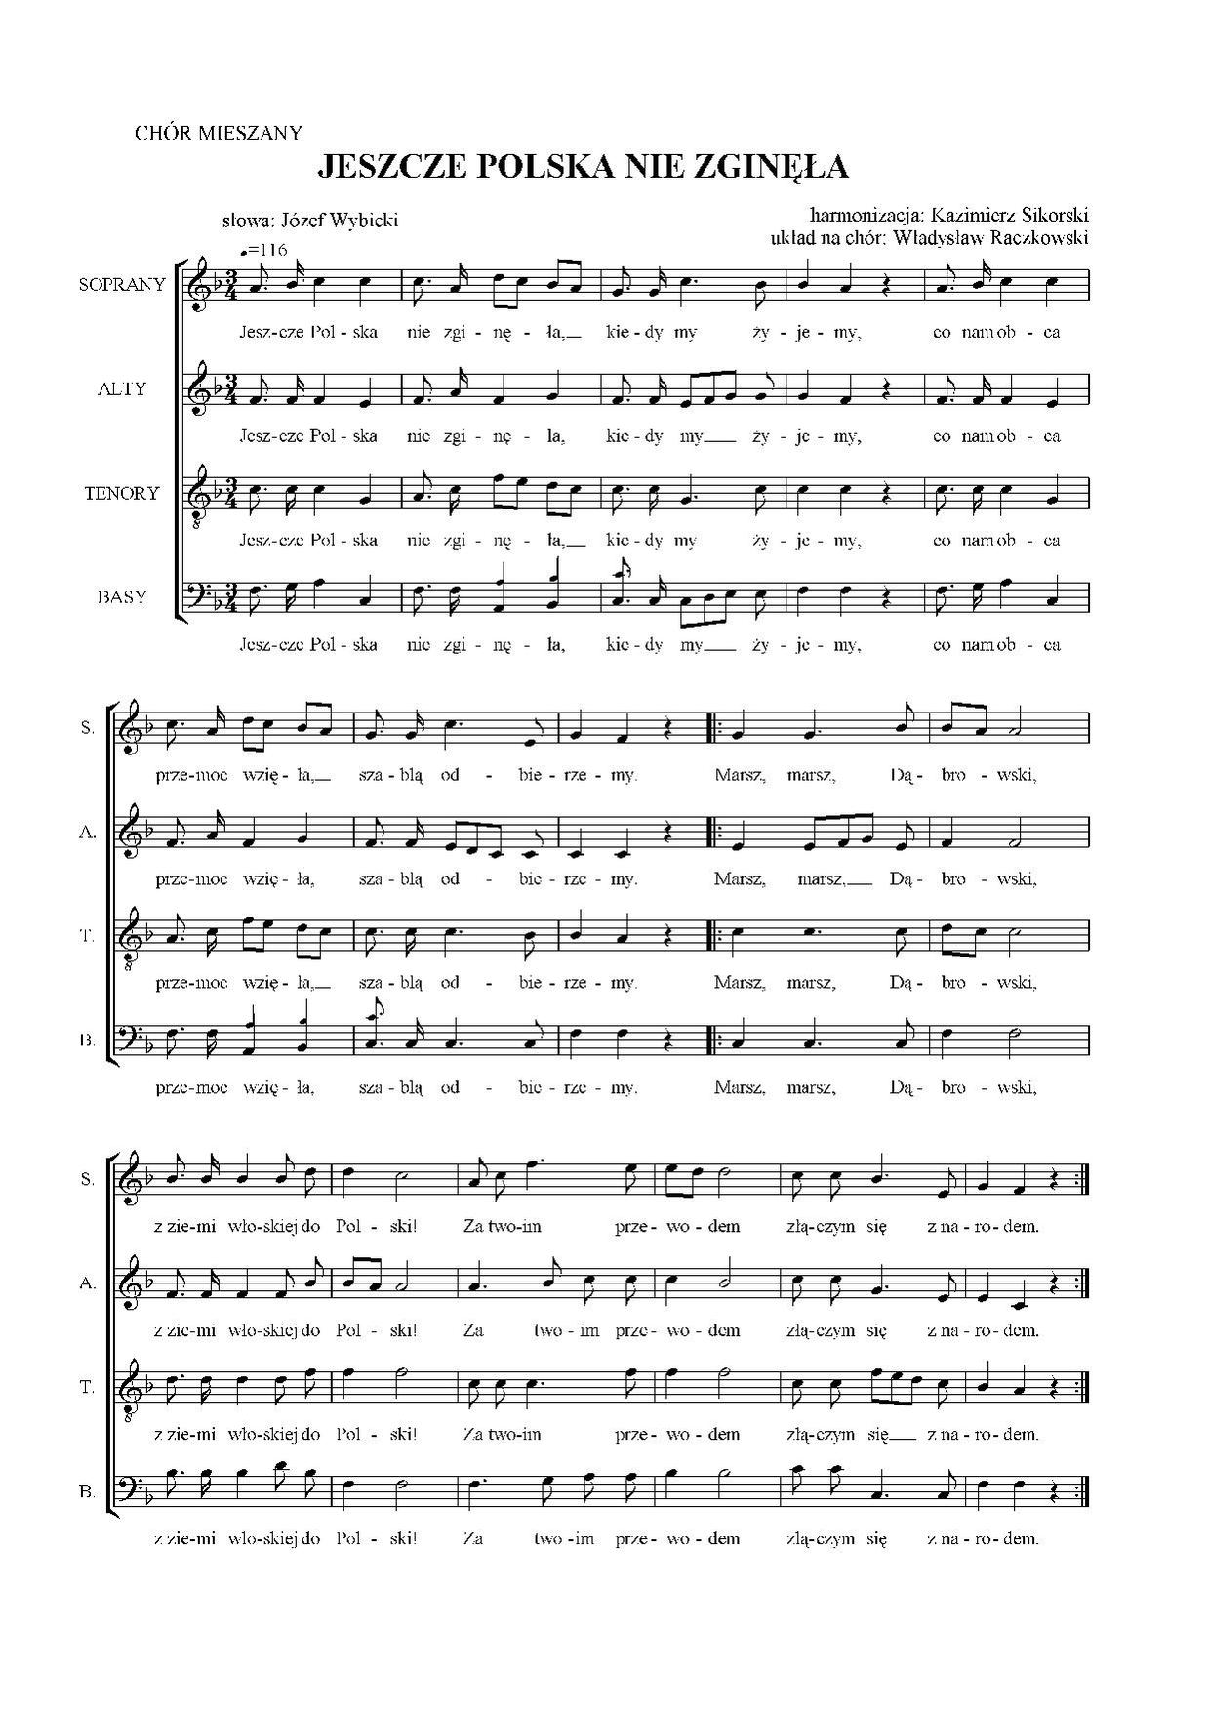](https://www.google.pl/url?sa=i&url=https%3A%2F%2Fcommons.wikimedia.org%2Fwiki%2FFile%3AMazurek_D%25C4%2585browskiego_mixed_choir.pdf&psig=AOvVaw2KX0_6GWKWivr92HtjEhdq&ust=1587979414030000&source=images&cd=vfe&ved=0CAIQjRxqFwoTCOiG8bnihekCFQAAAAAdAAAAABAS)