[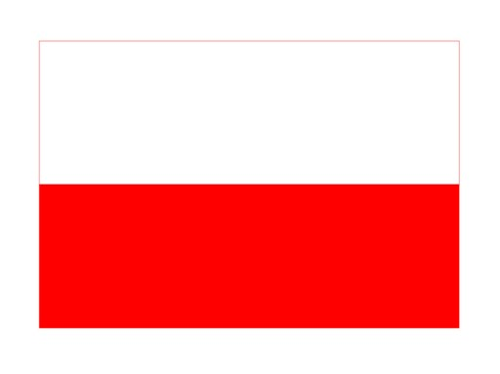](https://www.google.pl/url?sa=i&url=https%3A%2F%2Fallegro.pl%2Foferta%2Fpolska-naklejka-8cm-na-auto-flaga-polski-wlepka-7412065309&psig=AOvVaw1HeA15Mr5g-kj37J7rDnAV&ust=1587815503408000&source=images&cd=vfe&ved=0CAIQjRxqFwoTCIiKjev_gOkCFQAAAAAdAAAAABAN)