[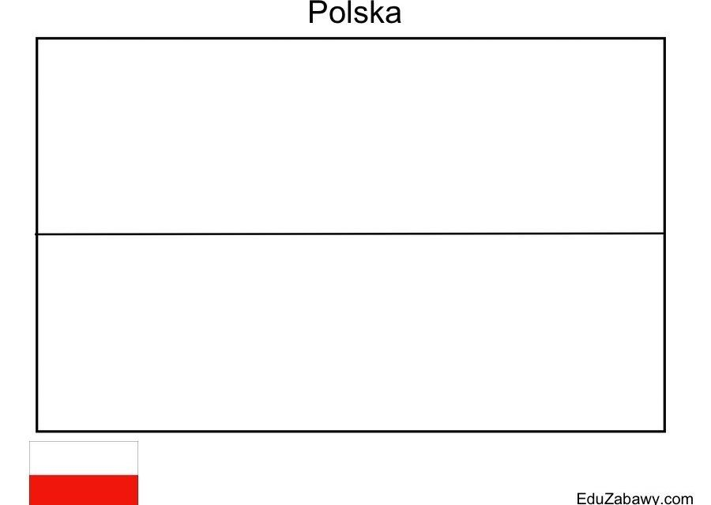](https://www.google.pl/url?sa=i&url=https%3A%2F%2Fwww.pinterest.com%2Fpin%2F589127194985346462%2F&psig=AOvVaw0EXszetVzVUt7LKJ2MZQpT&ust=1587980915801000&source=images&cd=vfe&ved=0CAIQjRxqFwoTCNiPoo7ohekCFQAAAAAdAAAAABAZ)