[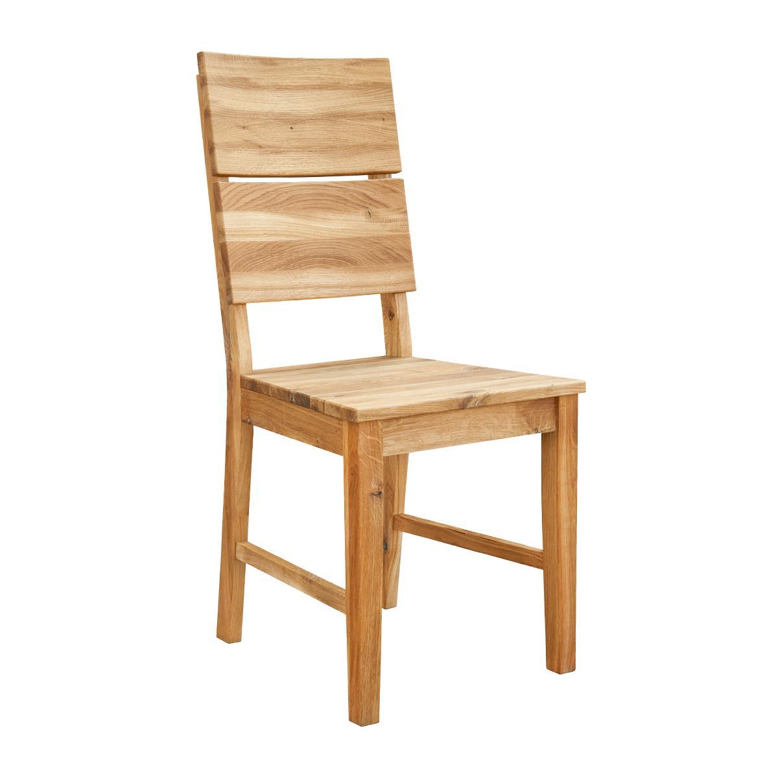](https://www.google.pl/url?sa=i&url=https%3A%2F%2Fmeblezych.pl%2Fkrzeslo-debowe-02&psig=AOvVaw2Uwaa-V3wHMyErEamyYFir&ust=1587829768474000&source=images&cd=vfe&ved=0CAIQjRxqFwoTCKiL-Py0gekCFQAAAAAdAAAAABAD)[](https://www.google.pl/url?sa=i&url=https%3A%2F%2Fwww.pinterest.com%2Fpin%2F711498441103477571%2F&psig=AOvVaw1EkLCqmbHnbg2pu45239t1&ust=1587830628607000&source=images&cd=vfe&ved=0CAIQjRxqFwoTCNiZgpe4gekCFQAAAAAdAAAAABAD)