[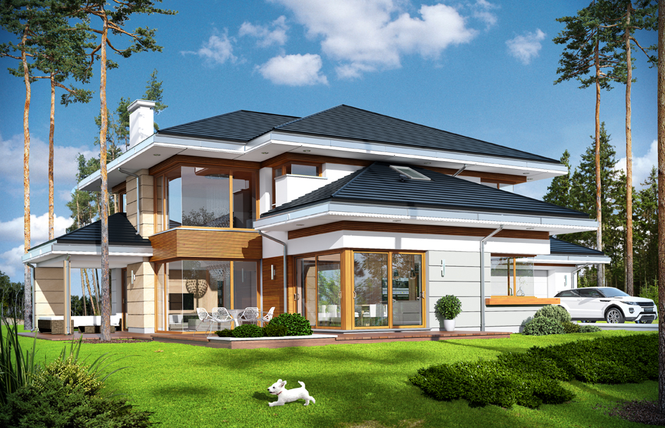](https://www.google.pl/url?sa=i&url=http%3A%2F%2F2f2017wiktoria.wex.pl%2F&psig=AOvVaw3PtS7iG1S5rv4jFrgG4dLz&ust=1587659633821000&source=images&cd=vfe&ved=0CAIQjRxqFwoTCPjtiZe7_OgCFQAAAAAdAAAAABAI) [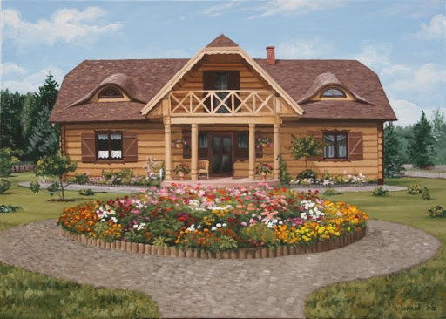](https://www.google.pl/url?sa=i&url=http%3A%2F%2Fwww.malarstwo-artnes.pl%2Fgaleria%2F1445702947%2Fobraz-domu-1&psig=AOvVaw3PtS7iG1S5rv4jFrgG4dLz&ust=1587659633821000&source=images&cd=vfe&ved=0CAIQjRxqFwoTCPjtiZe7_OgCFQAAAAAdAAAAABAX)

[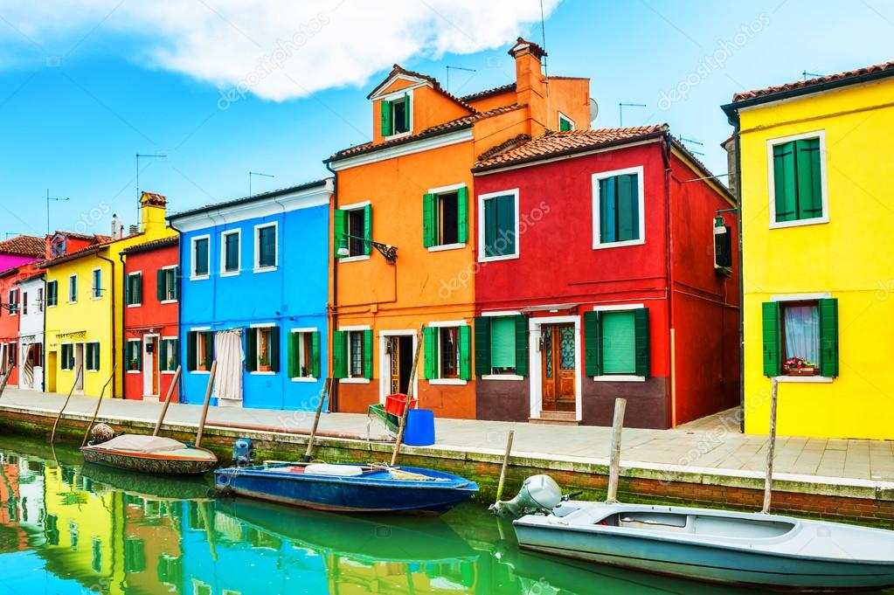](https://www.google.pl/url?sa=i&url=https%3A%2F%2Fdepositphotos.com%2F118594420%2Fstock-photo-colorful-houses-in-burano-island.html&psig=AOvVaw3PtS7iG1S5rv4jFrgG4dLz&ust=1587659633821000&source=images&cd=vfe&ved=0CAIQjRxqFwoTCPjtiZe7_OgCFQAAAAAdAAAAABAh) [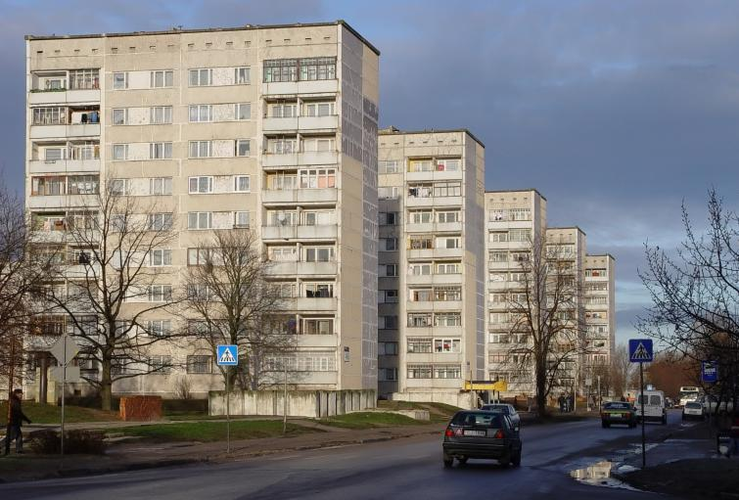](https://www.google.pl/url?sa=i&url=http%3A%2F%2Fregiodom.pl%2Fportal%2Fkredyty%2Fkredyt-hipoteczny%2Fodwrocona-hipoteka-odwrocony-kredyt-hipoteczny&psig=AOvVaw18DoRs3orcRPGZ-qbqjEIR&ust=1587660170788000&source=images&cd=vfe&ved=0CAIQjRxqFwoTCNCbvKu9_OgCFQAAAAAdAAAAABAJ)

[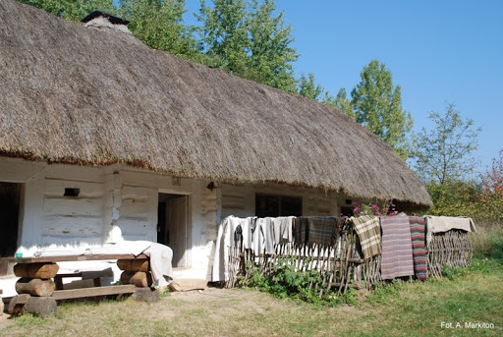](https://www.google.pl/url?sa=i&url=http%3A%2F%2Fpik.kielce.pl%2Fatrakcje-turystyczne%2Fbudowle-uzytecznosci-publicznej%2F18649-park-etnograficzny-w-tokarni-chalupa-ze-swiatnik.html&psig=AOvVaw1Ursdfaq5oxAjTgSnnRT5L&ust=1587660257242000&source=images&cd=vfe&ved=0CAIQjRxqFwoTCKD9oMe9_OgCFQAAAAAdAAAAABAD)