[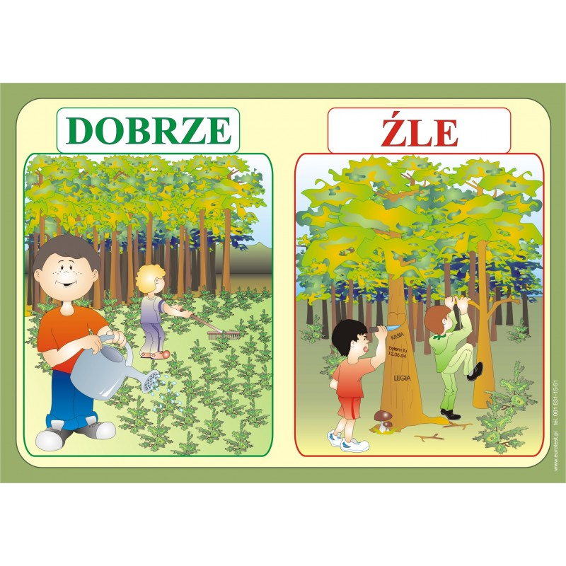](https://www.google.pl/url?sa=i&url=https%3A%2F%2Feurotest.pl%2Fhome%2F47-las-i-ochrona-srodowiska.html&psig=AOvVaw3NFOU3Jq_faQEwPZEf_wev&ust=1587124307331000&source=images&cd=vfe&ved=0CAIQjRxqFwoTCICbo_zw7OgCFQAAAAAdAAAAABAI)[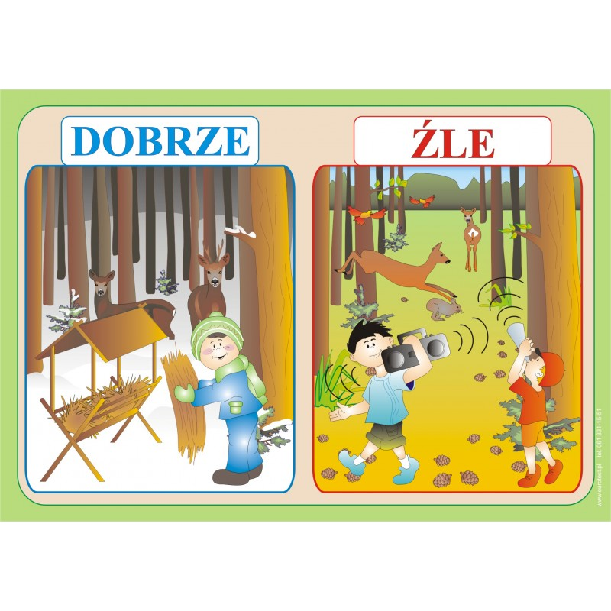](https://www.google.pl/url?sa=i&url=https%3A%2F%2Feurotest.pl%2Fhome%2F47-las-i-ochrona-srodowiska.html&psig=AOvVaw3NFOU3Jq_faQEwPZEf_wev&ust=1587124307331000&source=images&cd=vfe&ved=0CAIQjRxqFwoTCICbo_zw7OgCFQAAAAAdAAAAABAN)[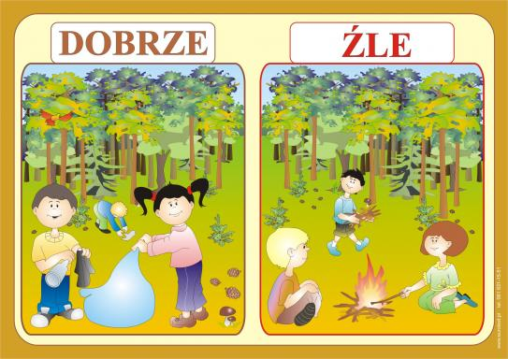](https://www.google.pl/url?sa=i&url=https%3A%2F%2Fwww.proabis.pl%2Foferta%2F%3Fprod_id%3D1034%26cat_id%3D2%26subcat_id%3D79&psig=AOvVaw3NFOU3Jq_faQEwPZEf_wev&ust=1587124307331000&source=images&cd=vfe&ved=0CAIQjRxqFwoTCICbo_zw7OgCFQAAAAAdAAAAABAR)

[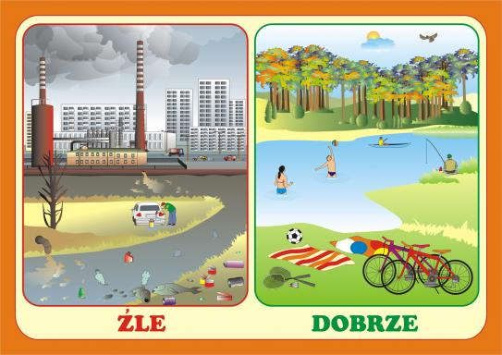](https://www.google.pl/url?sa=i&url=https%3A%2F%2Fwww.pomocedydaktyczne.eu%2Fp2263%2Cplansze-edukacyjne-cd-ekologia-na-co-dzien.html&psig=AOvVaw3NFOU3Jq_faQEwPZEf_wev&ust=1587124307331000&source=images&cd=vfe&ved=0CAIQjRxqFwoTCICbo_zw7OgCFQAAAAAdAAAAABAW)