[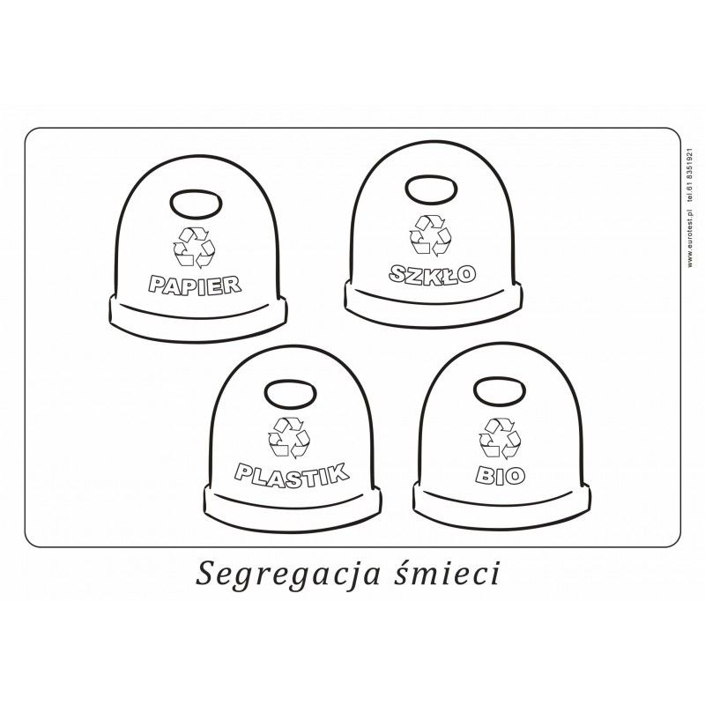](https://www.google.pl/url?sa=i&url=https%3A%2F%2Fwww.pinterest.com%2Fpin%2F664914332466975479%2F&psig=AOvVaw3Zi42bjd7XGgMQkjtXLhkO&ust=1586939403221000&source=images&cd=vfe&ved=0CAIQjRxqFwoTCIj_-43A5-gCFQAAAAAdAAAAABAb)