[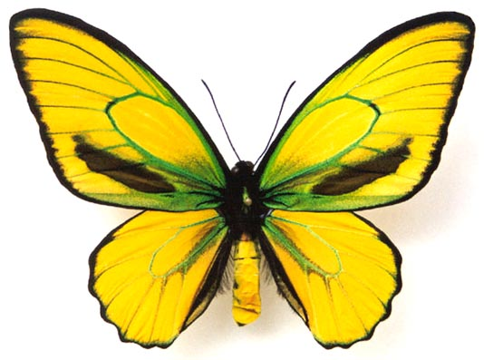](https://www.google.pl/url?sa=i&url=https%3A%2F%2Fpuzzlefactory.pl%2Fpl%2Fpuzzle%2Fgraj%2Fzwierzeta%2F112863-motyl-%25C5%25BC%25C3%25B3%25C5%2582ty&psig=AOvVaw3xACXsDj8SI9pTfBwXkadr&ust=1586456110547000&source=images&cd=vfe&ved=0CAIQjRxqFwoTCLjg4d232egCFQAAAAAdAAAAABAE) [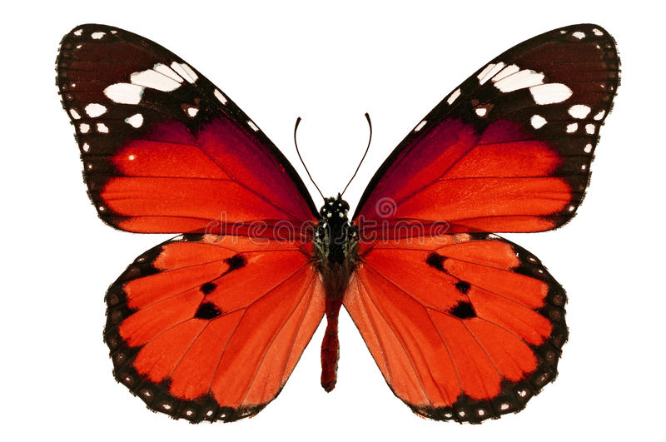](https://www.google.pl/url?sa=i&url=https%3A%2F%2Fpl.dreamstime.com%2Fzdj%25C4%2599cie-stock-czerwony-motyl-image46586703&psig=AOvVaw3SnuIpVa_O72HwK3Nf36AB&ust=1586456229373000&source=images&cd=vfe&ved=0CAIQjRxqFwoTCIjewpO42egCFQAAAAAdAAAAABAl) [](https://www.google.pl/url?sa=i&url=https%3A%2F%2Fdepositphotos.com%2F12458255%2Fstock-photo-violet-butterfly-isolated-on-white.html&psig=AOvVaw0eTy5dtXtBIJCc8a9WWpOu&ust=1586456409309000&source=images&cd=vfe&ved=0CAIQjRxqFwoTCMin2-u42egCFQAAAAAdAAAAABAf) [](https://www.google.pl/url?sa=i&url=https%3A%2F%2Fmyloview.pl%2Ffototapeta-piekny-niebieski-motyl-akwarela-odizolowane-na-bialym-nr-58A113B&psig=AOvVaw2MKa_-SFbjruisSCMNdRlm&ust=1586456577771000&source=images&cd=vfe&ved=0CAIQjRxqFwoTCKC38ru52egCFQAAAAAdAAAAABAe)