[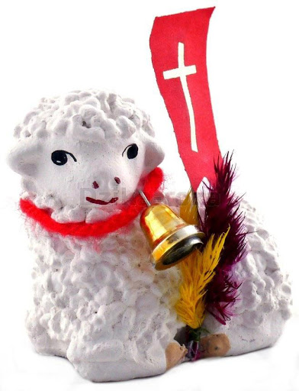](https://www.google.pl/url?sa=i&url=http%3A%2F%2Fdewocjonalia-roza.pl%2Fbaranek-wielkanocny-p-887.html&psig=AOvVaw1yNQ8ivVvVYOKc5Qg2SETe&ust=1585820694175000&source=images&cd=vfe&ved=0CAIQjRxqFwoTCIiV8v75xugCFQAAAAAdAAAAABAD) [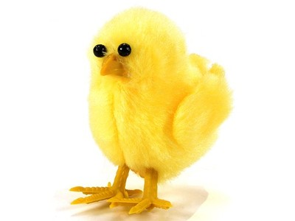](https://www.google.pl/url?sa=i&url=https%3A%2F%2Farchiwum.allegro.pl%2Foferta%2Fkurczak-kurczaki-wielkanoc-stroik-xl-kurka-6cm-ds-i6710136036.html&psig=AOvVaw1w52m-ZSsROsE0koYlOZo7&ust=1585821116383000&source=images&cd=vfe&ved=0CAIQjRxqFwoTCPCQn5v6xugCFQAAAAAdAAAAABAV)

[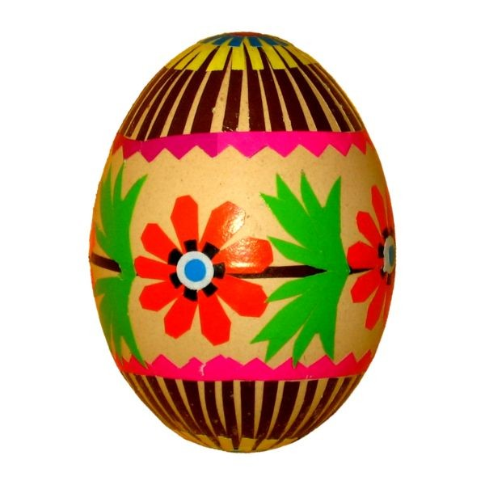](https://www.google.pl/url?sa=i&url=https%3A%2F%2Fpuzzlefactory.pl%2Fpl%2Fpuzzle%2Fgraj%2Fwielkanoc%2F159025-kolorowa-pisanka-ludowa&psig=AOvVaw2CjP7eYil6V_UqjDVdvK8X&ust=1585821233963000&source=images&cd=vfe&ved=0CAIQjRxqFwoTCPD3tM76xugCFQAAAAAdAAAAABAJ) [](https://www.google.pl/url?sa=i&url=https%3A%2F%2Fhaft-wzory.pl%2Fprodukt%2Fbazie-haft-komputerowy-9cm-x-175cm%2F&psig=AOvVaw0Vbf3kbsfoOExkf80q6rew&ust=1585821306896000&source=images&cd=vfe&ved=0CAIQjRxqFwoTCNDtwfH6xugCFQAAAAAdAAAAABAI) [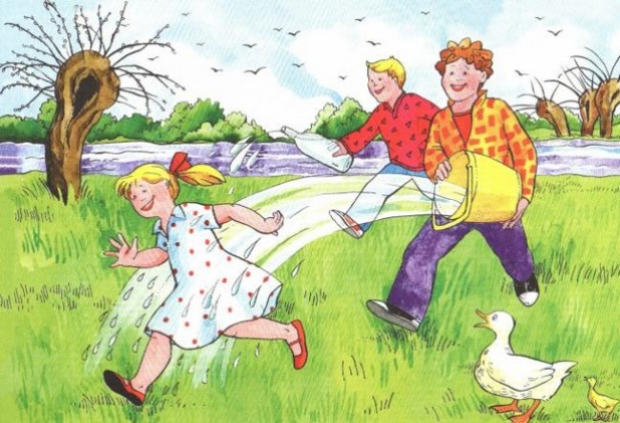](https://www.google.pl/url?sa=i&url=https%3A%2F%2Fwww.laskonline.pl%2Fart1459020325%2Cwielkanocne-lanie-czyli-smigus-dyngus&psig=AOvVaw0COVxmVDUQocuxaNR9Jd9y&ust=1585821371423000&source=images&cd=vfe&ved=0CAIQjRxqFwoTCICUzZH7xugCFQAAAAAdAAAAABAO)