[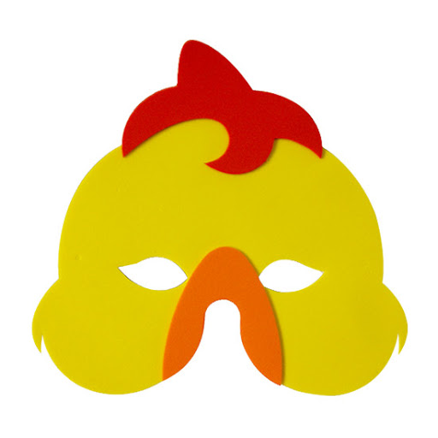](https://www.google.pl/url?sa=i&url=http%3A%2F%2Fwww.millytoys.com.br%2Fprodutos%2Fmascaras&psig=AOvVaw1hT2e3KX9Um-_hsu82j7yf&ust=1585818059465000&source=images&cd=vfe&ved=0CAIQjRxqFwoTCJDH96rvxugCFQAAAAAdAAAAABAh)