[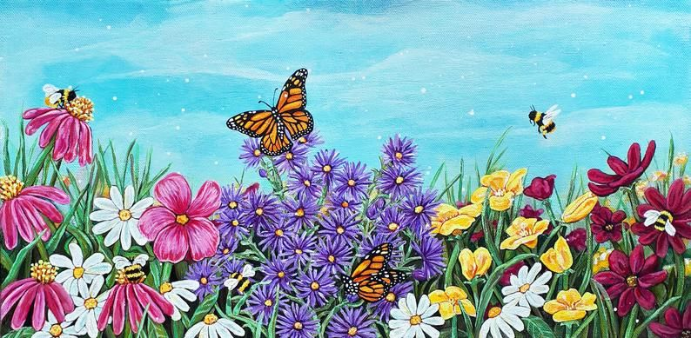](https://www.google.pl/url?sa=i&url=https%3A%2F%2Fwww.pinterest.com%2Fpin%2F221380137921201786%2F&psig=AOvVaw2dBVr9358_g2LBRVD4EZhN&ust=1589470557484000&source=images&cd=vfe&ved=0CAIQjRxqFwoTCIDPnbKVsekCFQAAAAAdAAAAABAm)